4.38: a) 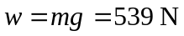
b)
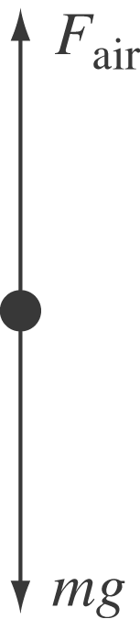
Downward velocity is decreasing so is upward and the net force should be upward. 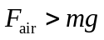, so the net force is upward.

c) Taking the upward direction as positive, the acceleration is

